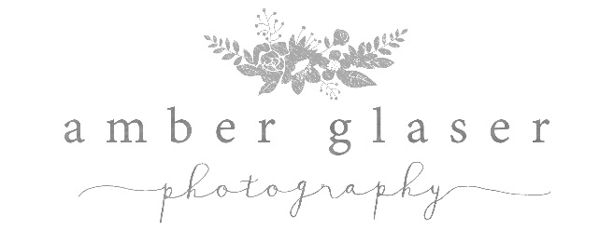

Newborns |Milestones

Newborn Session Fee $200
-Half due upon booking, in order to hold your spot.
-Total must be paid before session, otherwise session will be canceled.
-Booking fee ($50) is non-refundable if you cancel or reschedule.
-Covers up to four hours shooting time.
-Location in SETX, unless discussed beforehand. Travel fees will apply if outside of this area.
-Outfit changes and personal props are welcome!
-Touch ups and editing are included! All proofs will be edited before showing.

Milestone Session Fee $450 ($150 Savings!)
Newborn | 3 Month | 6 Months | 9 Months | One Year + Cake Smash
-Must be paid in full upfront

A La Carte Products (50% off if purchased with another package)
4x6- $20
5x7- $30
8x10- $60
11x14- $150
16x20- $200
8 wallets- $60
11x14 & 12x12 Gallery Wrap Canvas- $200
16x16 & 16x20 Gallery Wrap Canvas- $275
24x24 & 24x36 Gallery Wrap Canvas- $300
11x14 Mounted Print- $175
16x20 Mounted Print- $225
8x10 Table Top Canvas- $70
- Digital Download- $50

Package One- $100
2- 8x10
3- 5x7
- Digital download

Package 2- $200
- 8x10
- 5x7
- 4x7
- Digital download

Package 3- $250
- 8x10
- 5x7
- Digital downloads

Package 4- $300
3-8x10
5- 5x7
3-4x6
3-Digital downloads

Digital images on cd or for download- $300 for complete collection, with print release.

